User interfaces

In order to represent the interactions between the system and the customers, we focused on the simplicity. We try to design these interfaces ensuring that they are as intuitive as possible. This is the main aspect becase our application is thought to be used also by older people.

**1.1 Mobile App: Citizens**

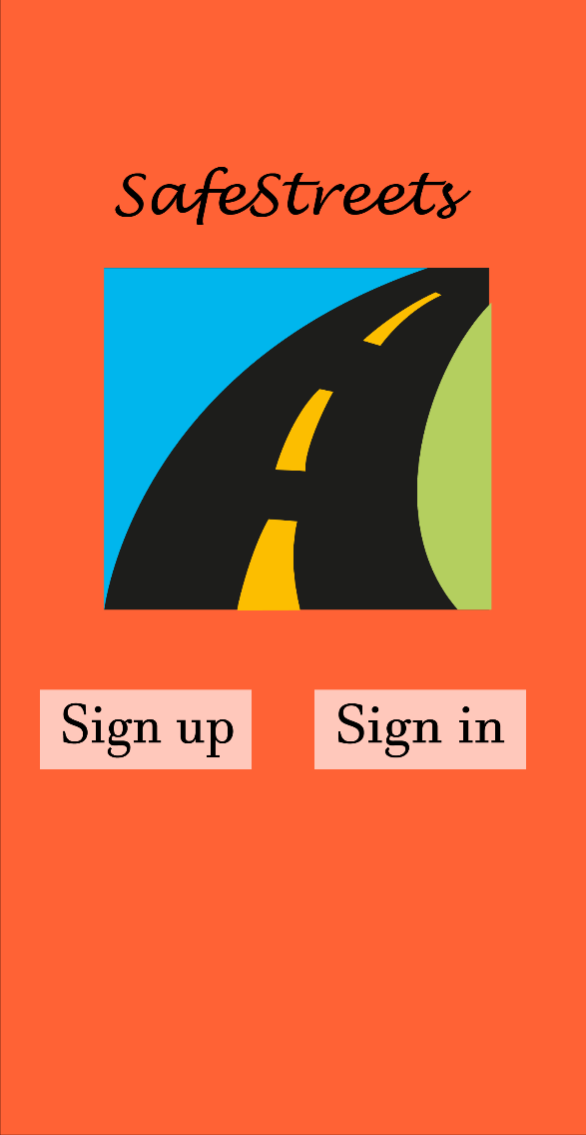 

(Figure 1.1.1) (Figure 1.1.2)

A guest can only do two actions: sign up, if he has not yet registered himself or,  
otherwise, sign in (Figure 1.1.1). In this case is required entering your own username and your own password (Figure 1.1.2).

 

(Figure 1.1.3) (Figure 1.1.4)

A citizen who wants to sign up has to insert his own data: firstname, lastname and fiscal code; then he has to choose an username and a password for his account (Figure 1.1.3). A registered user can access to the menu and in particular he can visit his profile, report a violation, view areas with most violations, view unsafe areas and finally view suggested interventions (Figure 1.1.4).

 

(Figure 1.1.5) (Figure 1.1.6)

In the first picture (Figure 1.1.5) is shown how an’ user menu should appear. He can access to his own reportings’ history and check if his request has been accepted, rejected or if it hasn’t yet been verified (Figure 1.1.6).

 

(Figure 1.1.7) (Figure 1.1.8)

If an user wants to signal a violation, he has to insert the date, the time and choose the type of the infringement between those proposed. In addition is required taking a photo in which the license plate is clearly visible and send the position (Figure 1.1.7).  
Concerning the areas with most violations, a customer is able to visualize them throw the map. Obviously, the zones with more offences are better highligthed (Figure 1.1.8).

 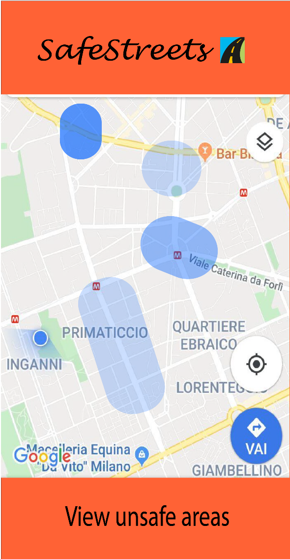

(Figure 1.1.9) (Figure 1.1.10)

In the first picture we can observe a pie chart which gives information about violations related to a certain zone (Figure 1.1.9). We can also see how areas with most accidents are represented in the map. As explained before, zones with more accidents are pointed out (Figure 1.1.10).

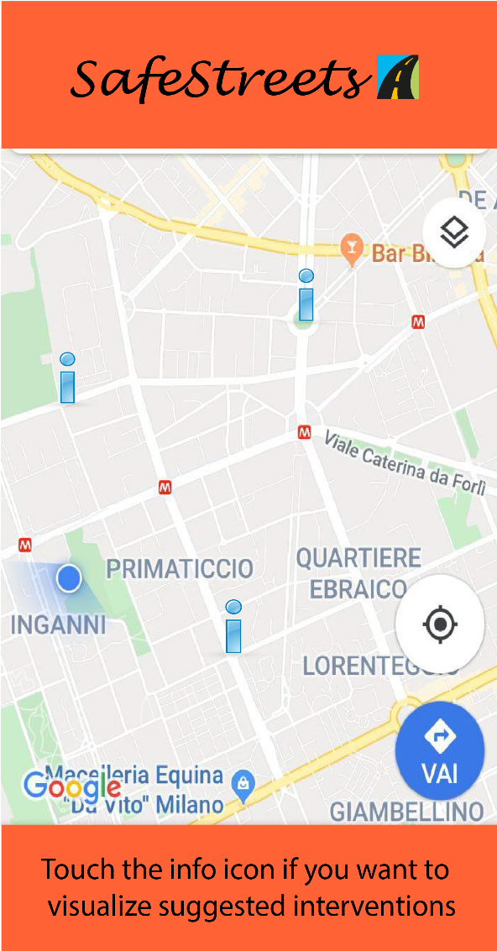 

(Figure 1.1.11) (Figure 1.1.12)

These interfaces relate to the suggestions made by Safestreets, crossing its own data with information about accidents. In the map we can see dangerous places which Safestreets advices to fix (Figure 1.1.11). It is also proposed the issue about the involved street and a possible solution (Figure 1.1.12).

**1.2 Mobile App: Authorities**

Authorities can only sign up with credentials provided by Safestreets; each Muncipality has a private account that is accessible to authorities who work for this Municipality. However, big cities which have different municipalities, one for each zone, have also several accounts. Obviously, authorities has their personal interfaces even if they can access to the same data available for citizens (such as area with most violations and statistics). In addition they have a list of incoming requests and they can generate tickets, reject reportings and point out accidents so that Safestreets is able to build statistics and identify unsafe areas. Some authorities interfaces are the same as those for citizens: we report the most rilevant below.

 

(Figure 1.2.1) (Figure 1.2.2)

Authorities have the list of the violations reported by citizens concerning their area of responsability and they can check if a past request has been verified or not (Figure 1.2.2). Moreover, they can access to the most rilevant information about a violation: after analyzing them (in particular the photo and the target license), they can refuse or accept the request and, consequently, generate a ticket (Figure 1.2.2).

**2.1 Web App**

The application is thought to be developed for mobiles but we report an example of web interface, because consulting charts and statistics through a browser could be very comfortable for both citizens and authorities.



(Figure 2.1.1)

This is an example of how our web application should show areas with most violations.